Test Case: tc002_SPX_Dev5_Crear_Requisicion_Spot_Tipo_Cobro_Project
Step 1 - Enter username and password and click to button Enter: Credentials Entered
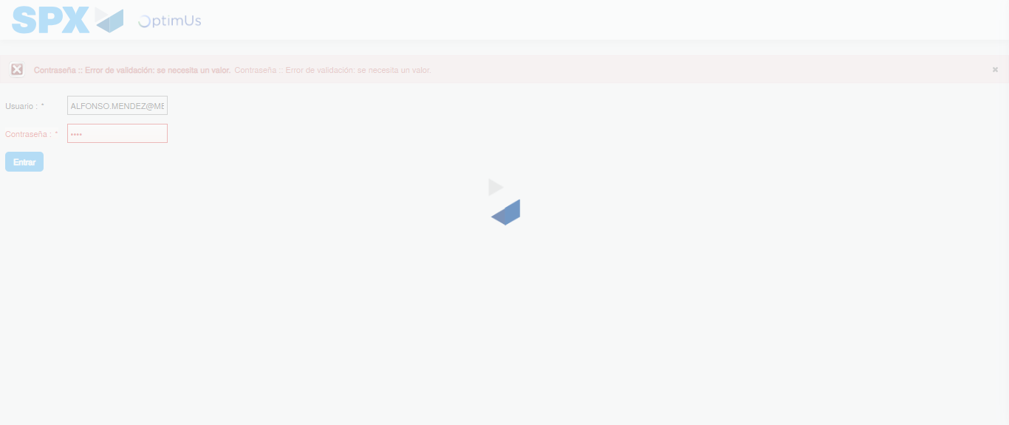Image file-name: QC_Testing-tc002_SPX_Dev5_Crear_Requisicion_Spot_Tipo_Cobro_Project-1784307904406

Step 2 - Select to UEN and Access to Spot Buy Requisitions : UEN Correctly selected and Correct access
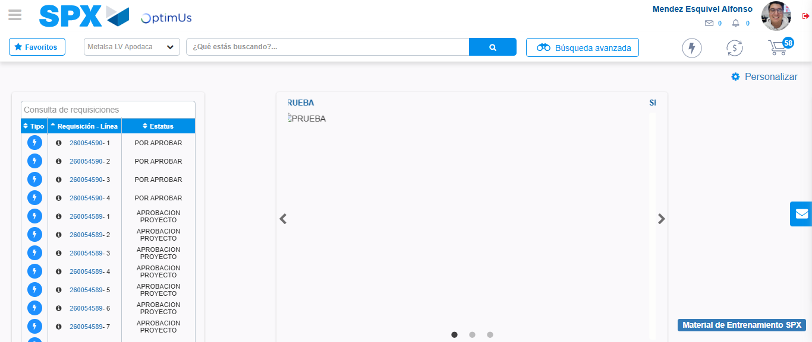Image file-name: QC_Testing-tc002_SPX_Dev5_Crear_Requisicion_Spot_Tipo_Cobro_Project-1784307973958

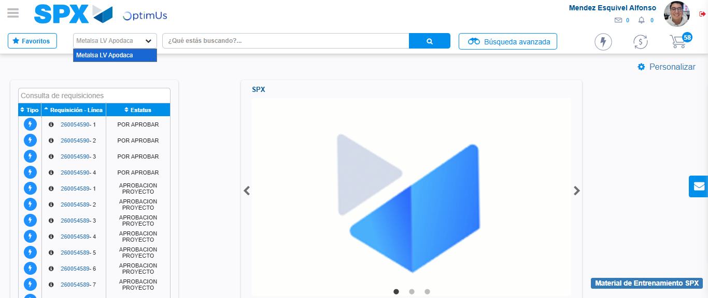Image file-name: QC_Testing-tc002_SPX_Dev5_Crear_Requisicion_Spot_Tipo_Cobro_Project-1784307976411

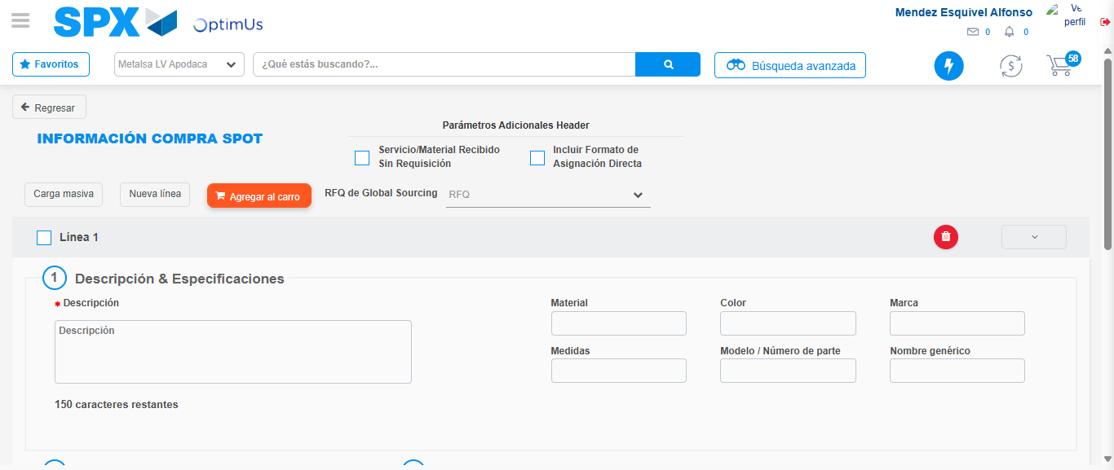Image file-name: QC_Testing-tc002_SPX_Dev5_Crear_Requisicion_Spot_Tipo_Cobro_Project-1784307983755

Step 3 - Data Capture Spot Buy Requisition: Data captured correctly
Image file-name: QC_Testing-tc002_SPX_Dev5_Crear_Requisicion_Spot_Tipo_Cobro_Project-1784307983986

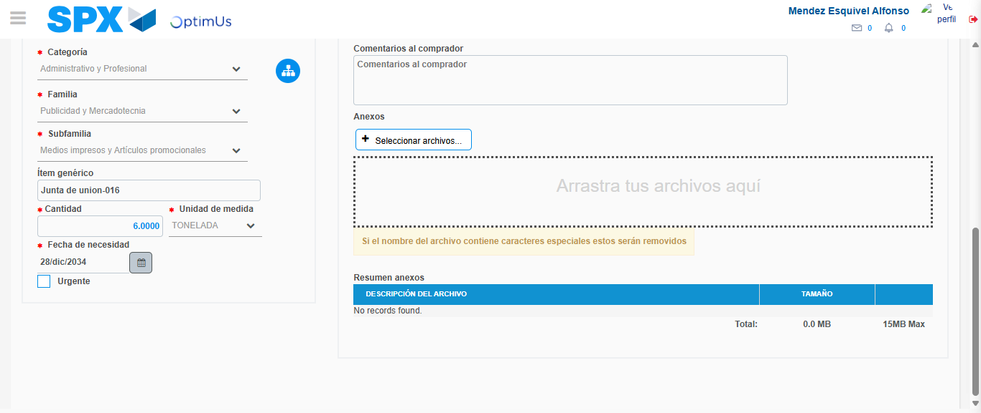Image file-name: QC_Testing-tc002_SPX_Dev5_Crear_Requisicion_Spot_Tipo_Cobro_Project-1784307994135

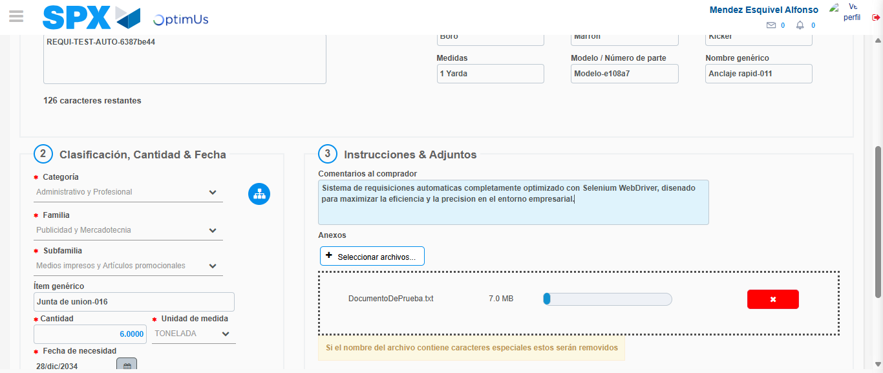Image file-name: QC_Testing-tc002_SPX_Dev5_Crear_Requisicion_Spot_Tipo_Cobro_Project-1784307994960

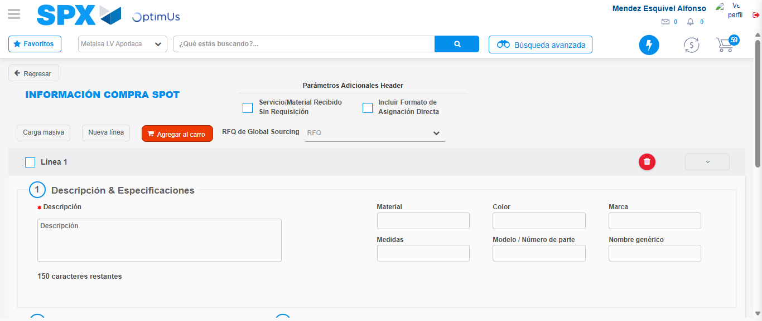Image file-name: QC_Testing-tc002_SPX_Dev5_Crear_Requisicion_Spot_Tipo_Cobro_Project-1784308003970

Step 7 - Return to Main Page SPX : Return to Main Page SPX
Image file-name: QC_Testing-tc002_SPX_Dev5_Crear_Requisicion_Spot_Tipo_Cobro_Project-1784307973958

Image file-name: QC_Testing-tc002_SPX_Dev5_Crear_Requisicion_Spot_Tipo_Cobro_Project-1784307976411

Image file-name: QC_Testing-tc002_SPX_Dev5_Crear_Requisicion_Spot_Tipo_Cobro_Project-1784307983755

Image file-name: QC_Testing-tc002_SPX_Dev5_Crear_Requisicion_Spot_Tipo_Cobro_Project-1784308006241

Image file-name: QC_Testing-tc002_SPX_Dev5_Crear_Requisicion_Spot_Tipo_Cobro_Project-1784308006415

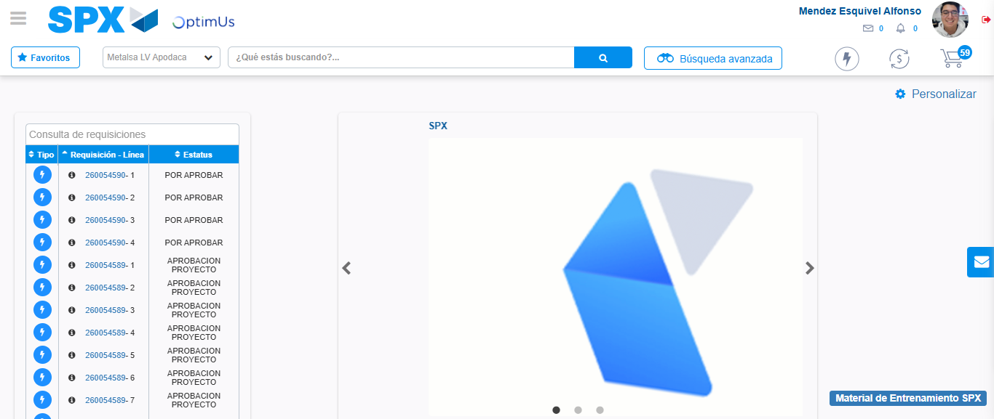Image file-name: QC_Testing-tc002_SPX_Dev5_Crear_Requisicion_Spot_Tipo_Cobro_Project-1784308027445

Step 8 - Log Out : Log Out SPX
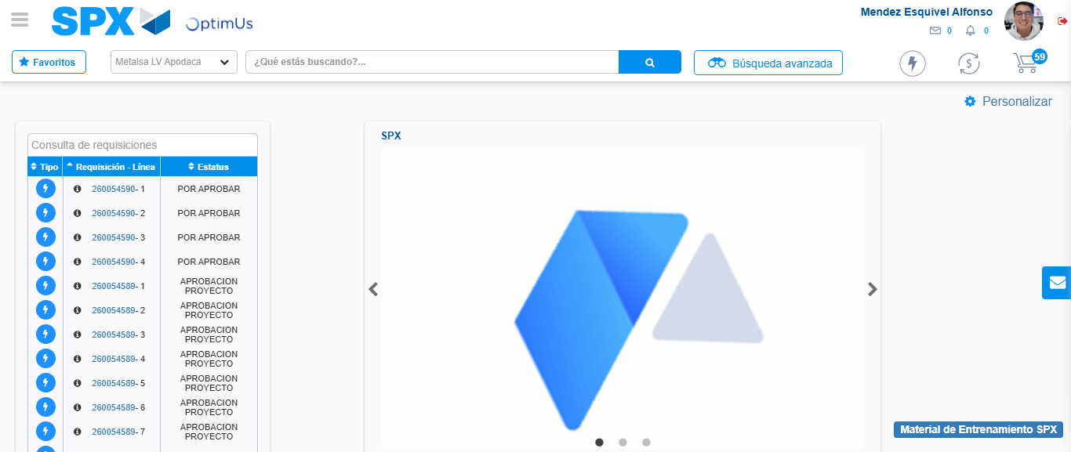Image file-name: QC_Testing-tc002_SPX_Dev5_Crear_Requisicion_Spot_Tipo_Cobro_Project-1784308027726

